Engduino Setup instructions
Note: You must have administrator privileges on your computer to install this software.
Using these instructions you can either program your Engduino with Touch Develop or with the Arduino IDE.
If you want to use your Engduino with Touch Develop then read Section 1, Using the Engduino with Touch Develop. If you want to use your Engduino with the Arduino IDE then read Section 2, Using the Engduino with the Arduino IDE.

These instructions are for the Windows operating system OnLY

Using the Engduino with Touch Develop

Follow the instructions here to install the software you need to use Touch Develop with the Engduino when the Engduino is plugged in to a USB port.
1. Install the Engduino IDE
Go to the Engduino website and download the installer for the IDE. It can be found here. Pick the appropriate installer according to the operating system you are running on your machine.
2. Install Python 2.7
The Touch Develop uploader requires Python version 2.7.8 or above it will not work with Python version 3. Download the install package, according to your operating system, from here and run the installer.
3. Install node.js
Go to the node.js website, download and run the appropriate installer for your operating system.
4. Update PATH Environment Variable
In the File Explorer, go to Control Panel > All Control Panel Items. Choose System from the available options.
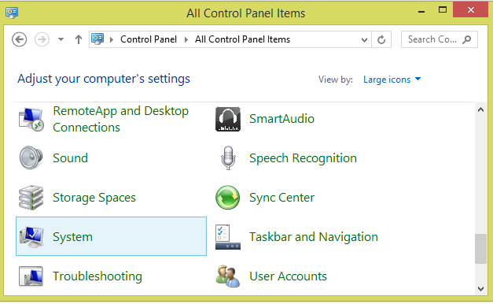
Go to Advanced system settings:
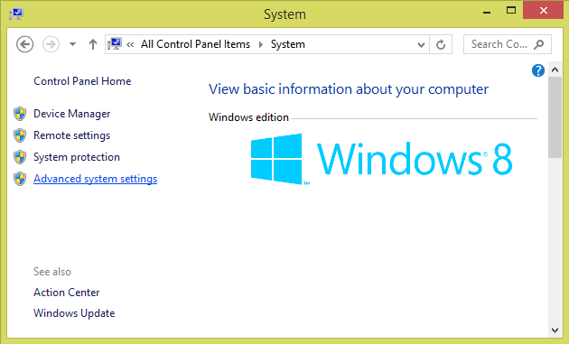
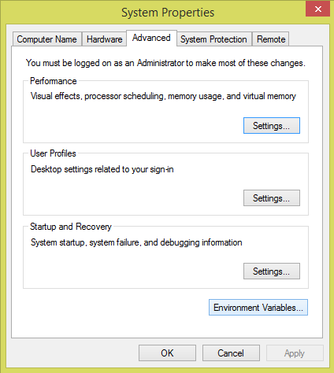
In the Advanced tab, pick Environment Variables.

Select the PATH variable, and click Edit. At the end of the already existing text, add this string:
;C:\Python27;C:\Python27\Scripts;
click OK, to save your changes.
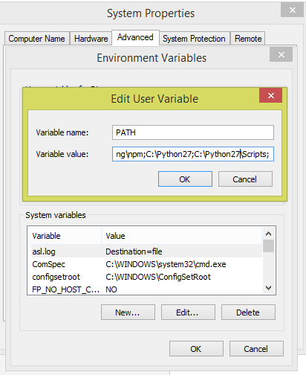
5. Install PlatformIO
Go to the PlatformIO website and click the ‘Get Started’ button followed by the ‘Install PlatformIO’ button. Look for the link for the installer script. Save the script get-platformio.py in one of your folders.
Open a command prompt window, and navigate to the folder where you saved the script. When you are inside the destination folder, type in the command python get-platformio.py, then wait for the install process to complete.
6. Create a New Folder to Store Your Touch Develop Local Files
Decide on a location where you wish to run Touch Develop Local, and create a new folder there. Note: do not run Touch Develop Local from the system32 folder.
After creating the new folder, open a command prompt window and use the cd command to navigate to it. Type in the command:
npm install -g http://aka.ms/touchdevelop.tgz
7. Run Touch Develop Local
After Touch Develop finishes installing, type in the command touchdevelop. A new browser window will open with an address http://local:4242/editor/beta...

8. Create Scripts and Upload to the Engduino
Now you can use Touch Develop on the Engduino. We recommend creating an account on the Touch Develop website so you can access your scripts and follow your own progress. When you want to export your code to the Engduino, click the arduino upload button.
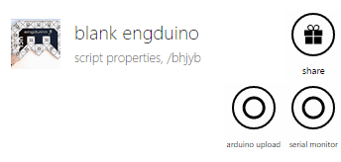

Congratulations! You just finished Setting Up!

Using the ENGDUINO with the ARduino IDE
The Engduino uses the Arduino Integrated Development Environment (IDE) with some additional libraries. You can download, install and configure the IDE using these instructions.
1. Install the Engduino IDE
If you have not done so already, go to the Engduino website and download the installer for the IDE, here. The Engduino libraries are already bundled in the installation package. Pick the appropriate installer according to the operating system you are running on your machine.
2. Configure the IDE
Plug in your Engduino to one of the USB ports on your computer and switch it on using the OFF / ON switch:
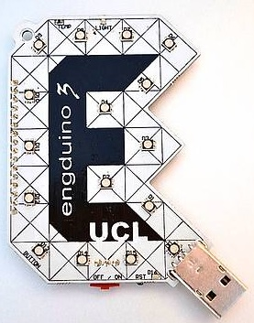
Start the Engduino IDE and select the Engduino V3 board by choosing: Tools Board EngduinoV3
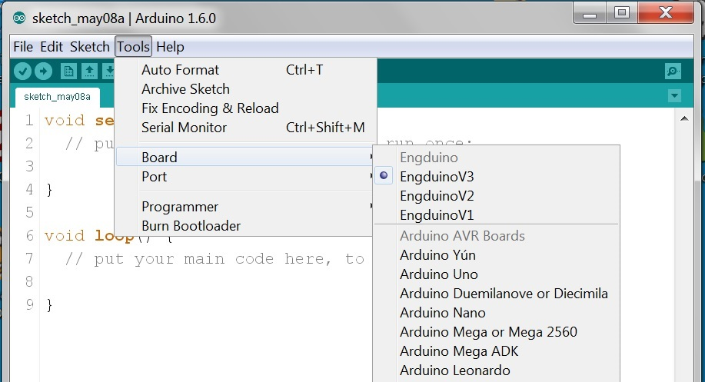
Find out what COM port the Engduino is using by navigating to the Control Panel and choosing View Devices and Printers. The Engduino should appear as either an EngduinoV3 or a Lilypad USB.
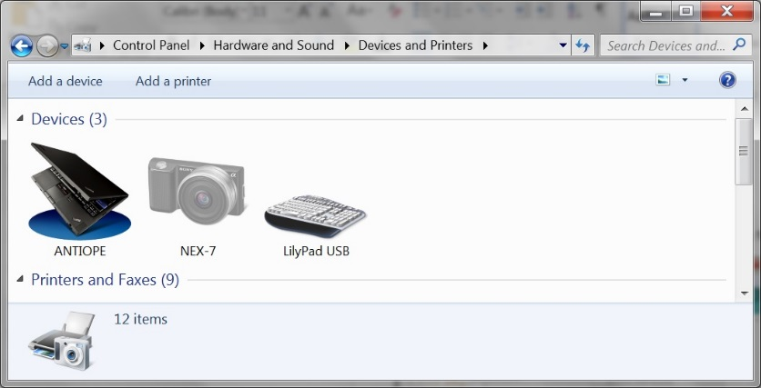
Double-click on the icon to view the device properties and select the Hardware tab. You should be able to see the COM port assigned to the device.
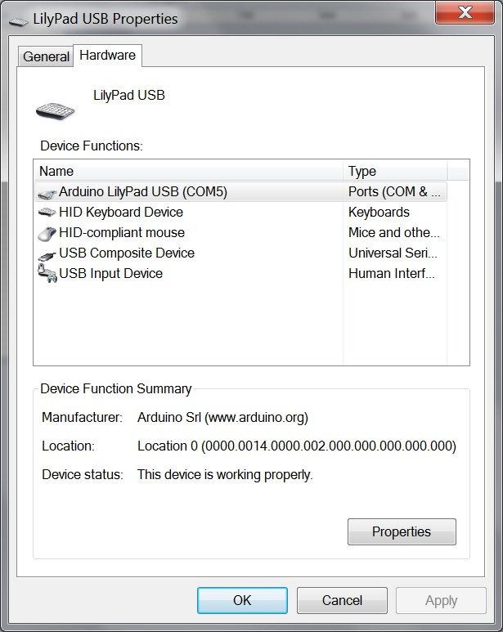
Now select the COM port in the Arduino IDE by choosing: Tools Port COMx where COMx is the COM port that your device is plugged in to.
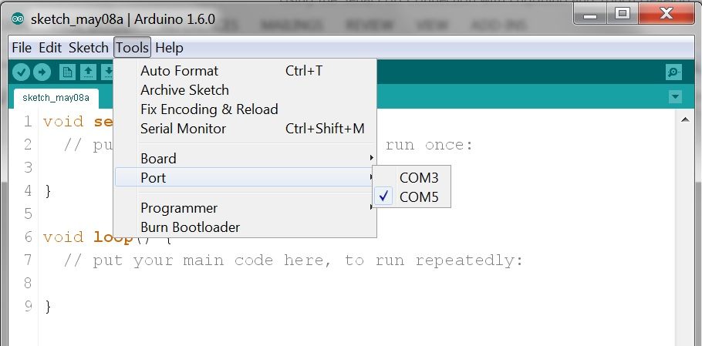

3. Run an example
Open a program from the Examples menu, for example: Examples 100.Engduino CycleLightRear.
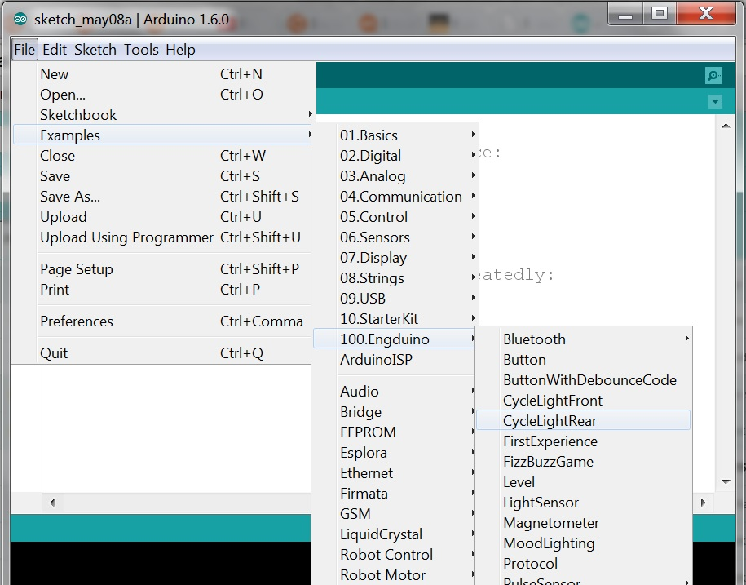

Compile and upload the code to the Engduino board by clicking the Upload button:
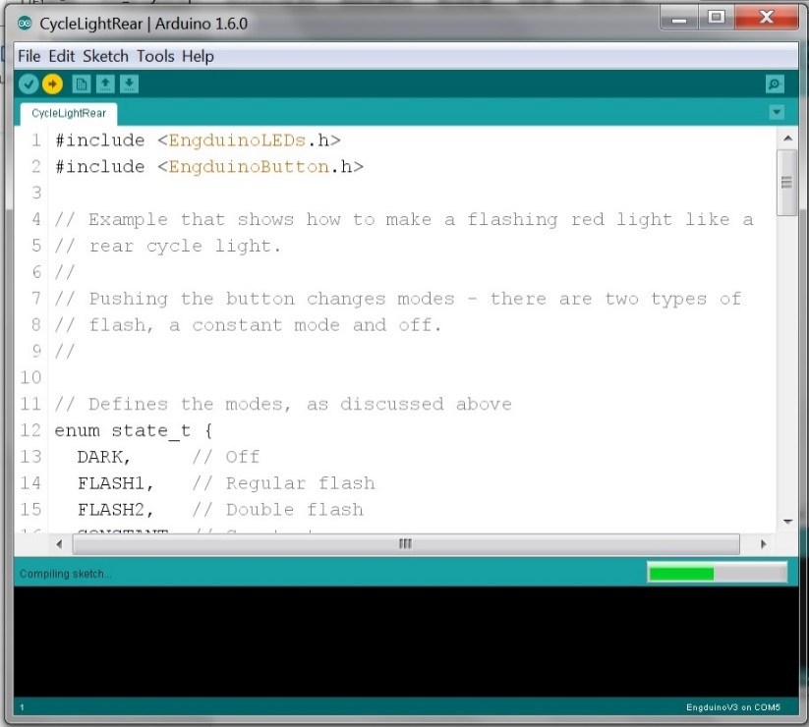
When the code has uploaded to the device, you should see flashing red LEDs on the Engduino.

Use the Change Directory command – cd to move from the home folder to the destination (e.g. if you saved the file onto the Desktop, you need to type in the command cd Desktop. Go to this WikiHow page for more information on the cd command.

